8th grade ANGLEŠČINA- NAVODILA ZA SAMOSTOJNO DELO MAREC 2020 ( 20.3. – 23. 3. 2020)
__________________________________________________________________________________

Pozdrav vsem vam! Upam, da ste uspeli rešiti vaje prvega sklopa. Upam tudi, da ste zdravi in da vam gre šolsko delo dobro od rok ! Off we go !

- Kako ti gre poimenovanje trgovin ? Je med njimi katera, ki je v Sloveniji ne poznamo ? npr.: a mall, an off-licence shop, a confectioner's, a flea market, a corner shop …..

- Can you solve the crossword ?

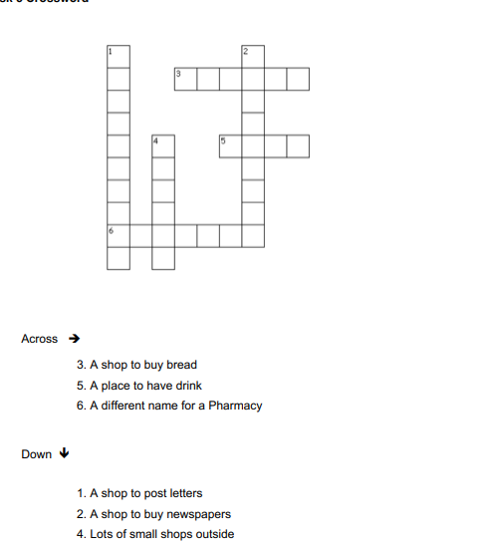

- MY FAMILY SHOPPING HABITS
UČB. Touchstone 8 , STR. 21, ex. 10a-answer the shopping quuestionnaire first and then write about the 10 c exercise in your books, p. 22. ( discussion questions)

You can learn some more interesting words about shopping .
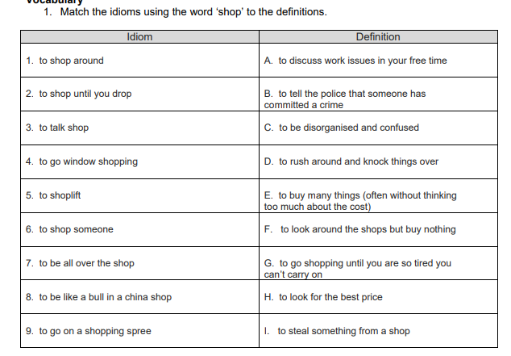

- Make a list of useful words with Slovene translations in your notebook. E.g. Do you remember how to say :

Čakati v vrsti :
Posebna ponudba
Artikli
Dolgočasje
Blagajna
Spletna prodaja
Ogledovanje izložb
Ukrasti v trgovini
zapraviti denar za nepomembne stvari
nakupovati do onemoglosti

- Then write about your family shopping habits using the following keylines:
- What is the shop you visit quite often ?
- how often you go there
- why it’s a good shop to visit
- The differences between shopping in large department stores and small independent shops.
- How people’s shopping habits have changed over the years.
- If you don't like shopping give your reasons as well.

Use the words and phrases from the book, p. 21 and 22.
Send me your written task on my e-mail till Wednesday, 24th March till noon.

Bye, Barbara Leban

